Kill Your Darlings: Image Curation
General AI Fluency Track — Week 3 Assignment
Submitted by Shraddha Chavan

1. Final Image Set (the keepers)
Nine images were selected across three real, working projects. All project screenshots below are real captures of functioning software — none were replaced with AI-generated mockups.

Student Information System
Python (Flask) + MySQL, 3-tier architecture. Modules: student records, attendance, results, dashboard.
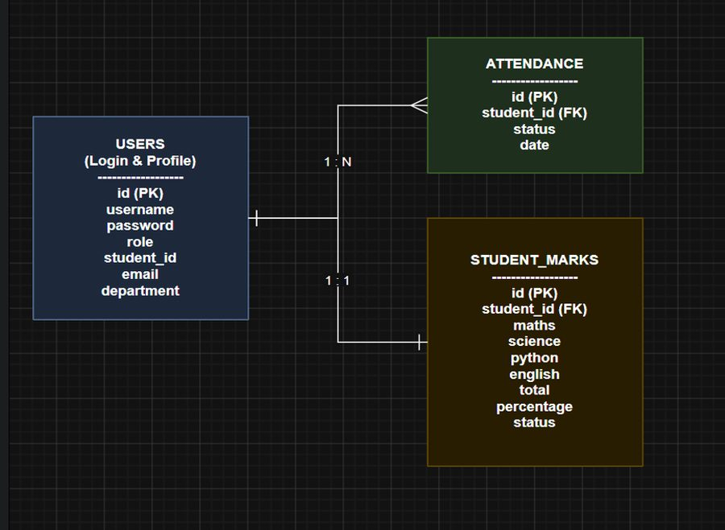
ER Diagram — shows the data model (Users, Attendance, Student_Marks)
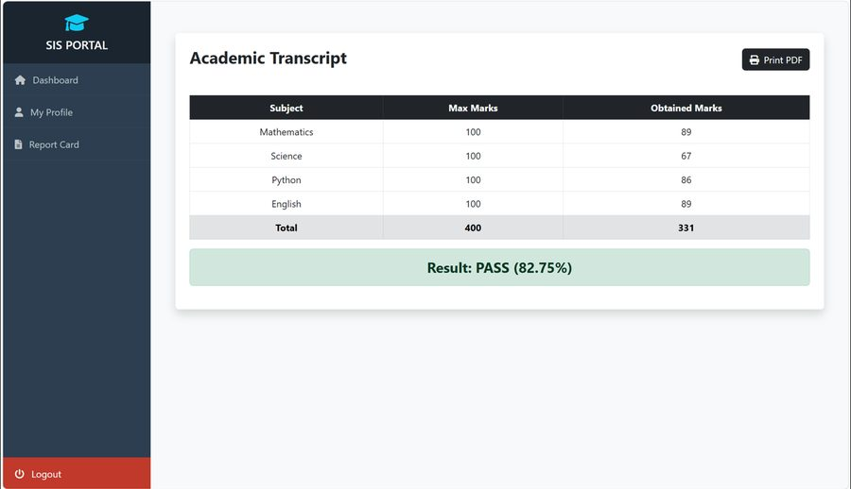
Academic Transcript / Report Card — subject-wise marks with automated pass/fail
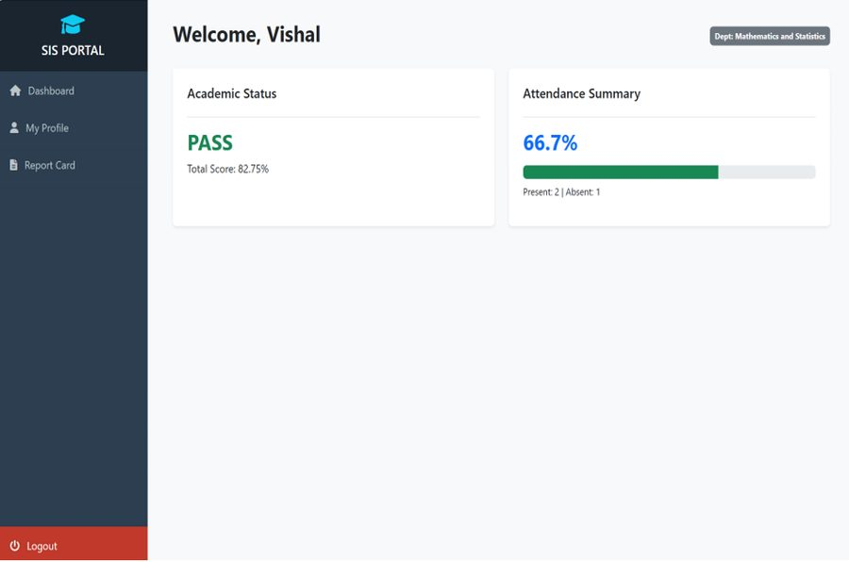
Student dashboard — automated attendance percentage and academic status

Student Result Management System (Node.js)
Rebuilt from an earlier console-based tool. HTTP server, file-based JSON storage, Chart.js visualization.
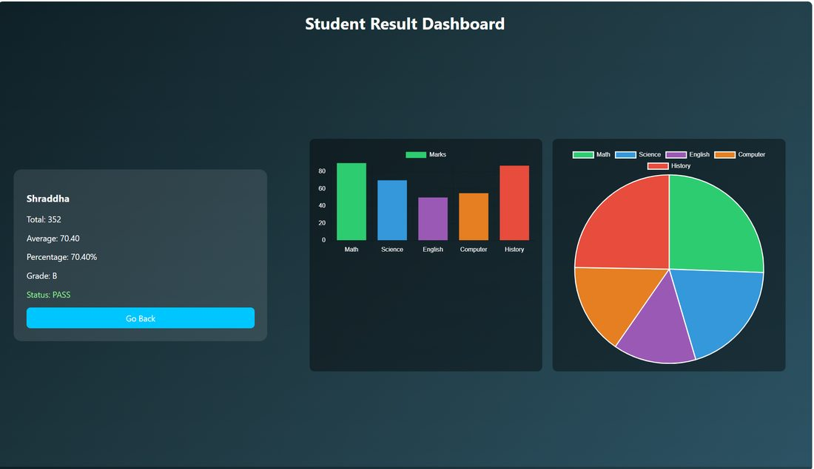
Result Dashboard — bar and pie chart visualization, the project's core feature

Company Ratings Correlation Dashboard
Pearson correlation analysis on a 40-response dataset. Built with SheetJS and Chart.js for a Mathematics & Statistics course.
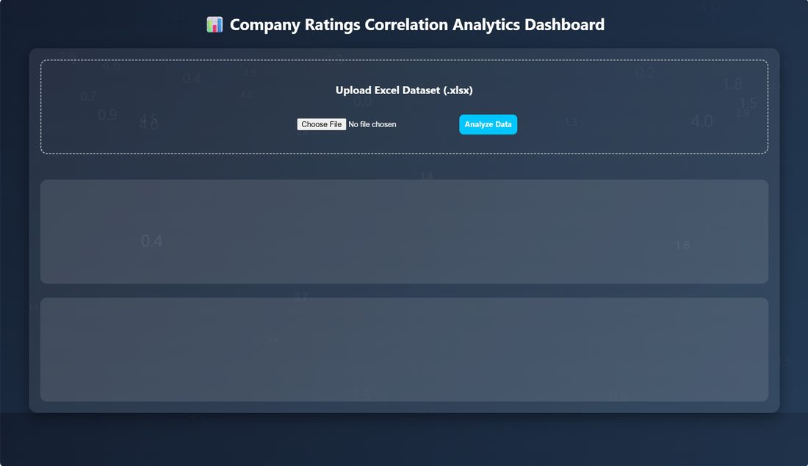
Upload state (before) — empty dashboard awaiting a dataset
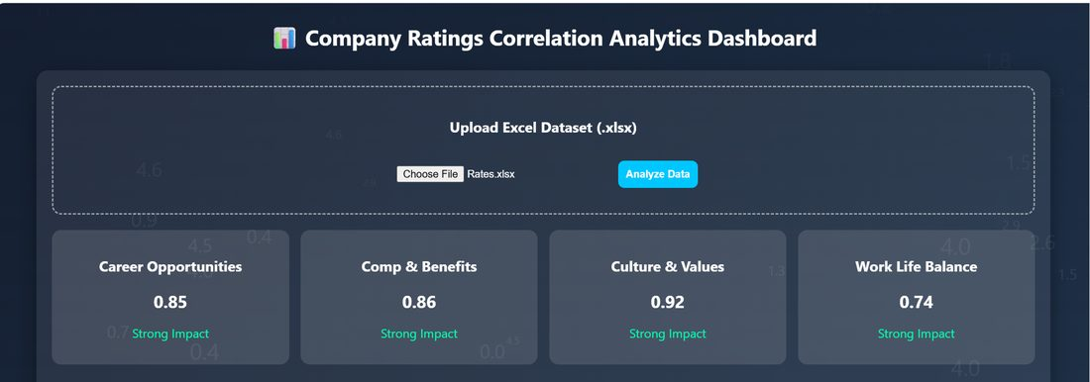
Populated correlation results — Career Opportunities, Comp & Benefits, Culture & Values, Work Life Balance
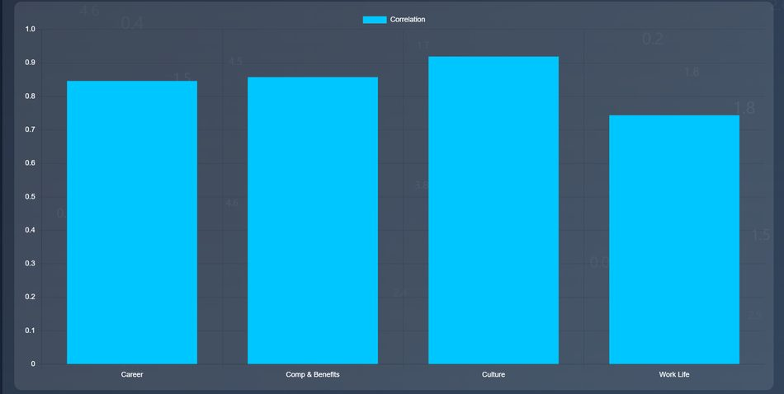
Bar chart of correlation values across the four factors
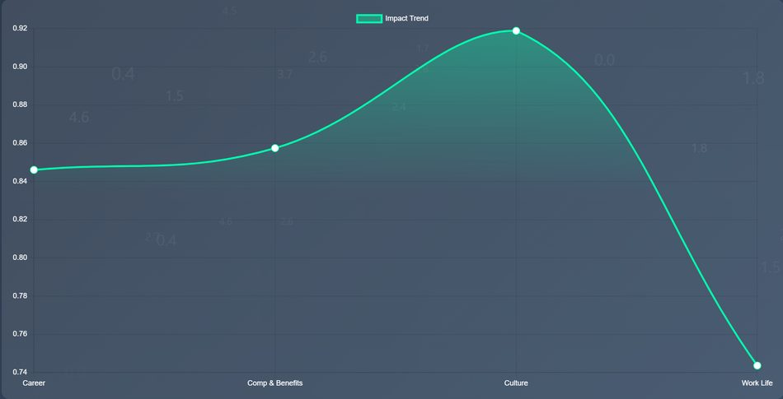
Line/trend chart of the same correlation data

Connective tissue (generated)
Two flat, geometric visuals were generated for use as hero texture and section dividers, sharing one locked prompt so they read as a set rather than a pile:
"...flat geometric illustration, cobalt #1E3AF2 and near-black #121212, one yellow #FFD400 accent, no gradients, no noise, confident minimalism"
- Hero texture — overlapping cobalt, warm-white, and one yellow flat shape on a near-black field
- Section divider icon set — database, chart, and code-bracket marks in the same three-shape, three-color language
Note: these two graphics were generated and reviewed in chat during the curation process; they are not embedded as image files in this document and would need to be exported separately before final layout.

Personal photo
A real photo of myself is used for the Bio section — no AI-generated stand-in, per the brief's requirement for anything that is a photo of a person.

2. Where I chose a real capture over AI
Every project screenshot in this set is a real capture of working software, even where the UI is visually plain. A portfolio's job is to prove the work exists and functions — a generated mockup cannot do that, no matter how polished it looks. AI was used only for the connective tissue between real proof points (hero texture, dividers), content that carries no evidentiary weight and exists purely to unify the page's visual rhythm.

3. Rejected image and reasoning
This is the discernment part of the assignment — the image below was seriously considered and then deliberately excluded.
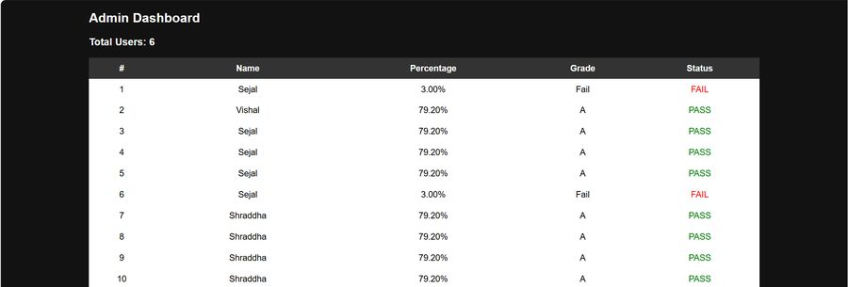
Excluded: Node.js Admin Dashboard
I initially planned to include the admin dashboard as proof of the multi-user / admin-view feature. But the underlying test data had accumulated repeated submissions under the same names with contradictory results — one entry shows “Sejal” both failing at 3% and passing at 79.20% across different rows, and “Shraddha” appears four times with identical values.
Rather than crop around the problem or present it as-is, I excluded the image entirely. A screenshot with visibly inconsistent data would undercut trust in the system more than the missing screenshot costs. The Result Dashboard already demonstrates the project's core differentiator — automated calculation plus chart-based visualization — so this was a nice-to-have that didn't meet the bar, not a critical gap in the proof.

4. Style consistency note
All generated images in this set share one locked style prompt (see Section 1), reused unchanged across both pieces so the AI-generated visuals form a coherent set rather than a mismatched pile, as required by the brief.

